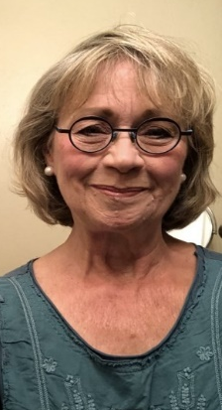
Quilt Art

by Mary Kay Hamilton
August 14 –September 30, 2022

Artist’s Reception
Sunday, August 21 from noon to 2pm
I only started quilting in my retirement. I’ve never considered myself an artist, but rather an amateur dilettante, who just plays with fabrics, colors, designs and random quirky ideas and inspirations. I have a lot fun and it keeps me out of trouble. (Or maybe in trouble!)

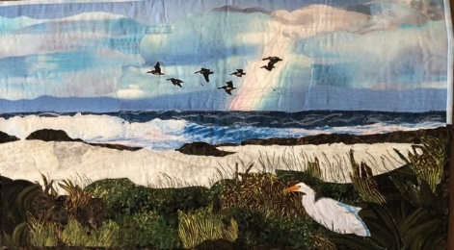
Many quilters follow patterns and have a good idea of how their piece will look when they are finished, with stunning results. I occasionally use patterns, especially for some lap and bed quilts, but mostly my art quilts are either inspired by photographs, or more likely just improvised. Which is to say I make them up as I go along. My art quilts evolve over time from vague idea to a finished product. Asilomar After a Rain
Once I begin, I frequently reconsider my choices, change fabrics, reassess colors, rearrange placement, and basically change my mind about what might look right or good. Oftentimes
the finished product has little resemblance to where it started. (I am a master with the
seam ripper!)
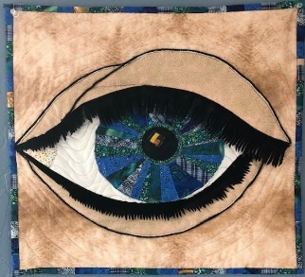
For example, one improvised quilt is “Eye See You” which evolved from a Monterey Peninsula Quilters’ Guild challenge. We were challenged to create the 18”x18” quilt that included a circle. I started by just sewing fabric together into a circle, then said, “Hey, that looks like an iris.” Then I developed the eye around it. Most other MPQG challenge quilts of mine evolved the same way, improvised.
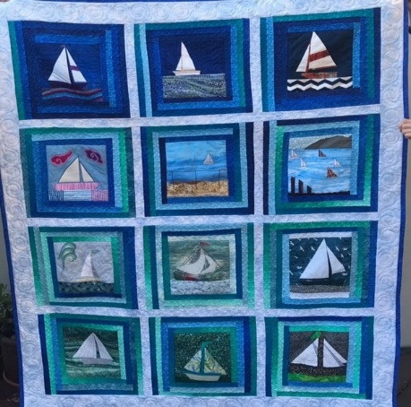
Eye See You

A few art quilts were inspired by photographs. “Asilomar After A Rain” is inspired by a Susan Lambert photo. The “Sailboats For Sid” is a quilt I made for my son Sid who sails. It morphed over time as I started taking photographs of sailboats around the bay and reproducing them in fabric.

Sailboats for Sid

